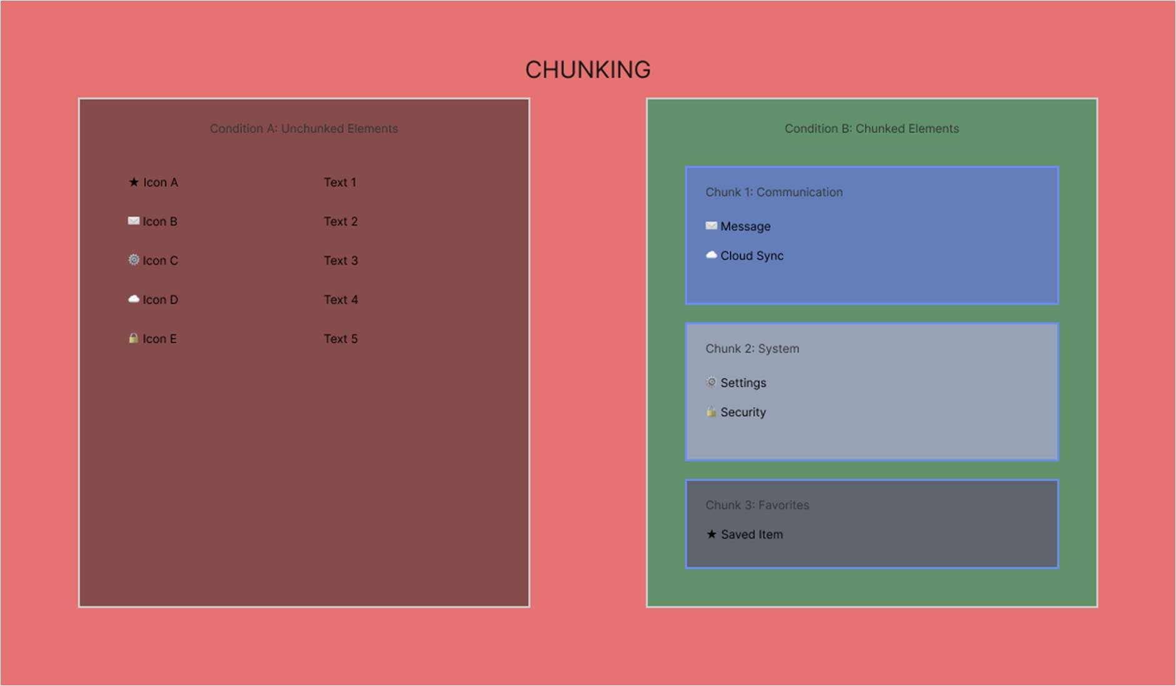
DESCRIPTION :

Left Side : presents information in an unchunked form, where all items are displayed as a single continuous list without any logical grouping or hierarchy. This forces users to process each element individually, increasing cognitive load and making it harder to scan, understand, and remember the information.

Right Side: organizes the same items into clearly labelled chunks based on their functionality. By grouping related elements together and visually separating them, the chunked layout reduces mental effort, improves clarity, and allows users to understand and locate information more quickly and efficiently.

